**Exercise 1 :**

Create a new repository, signup with GitLab and register your credentials

Login to GitLab and create a “GitDemo” project

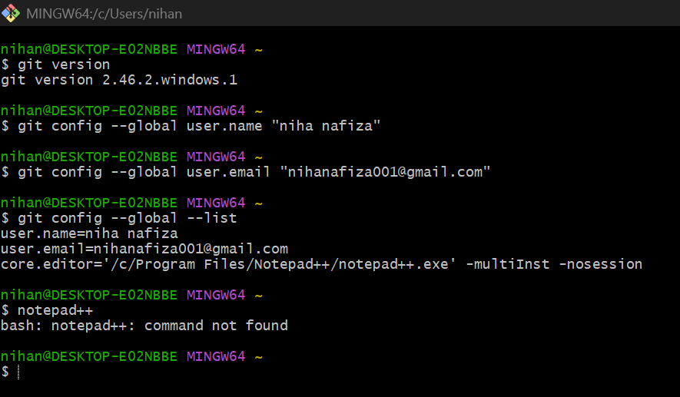

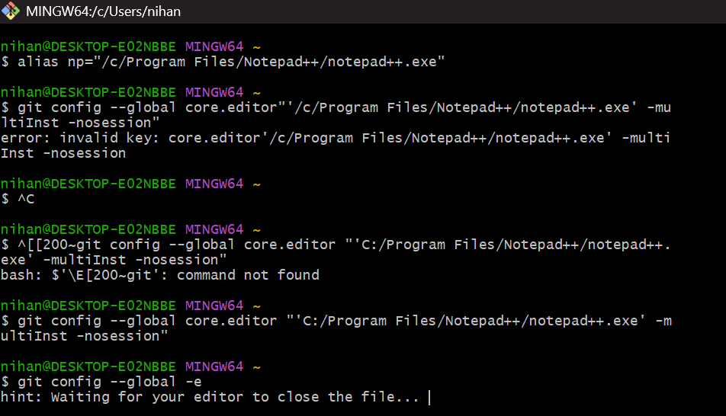

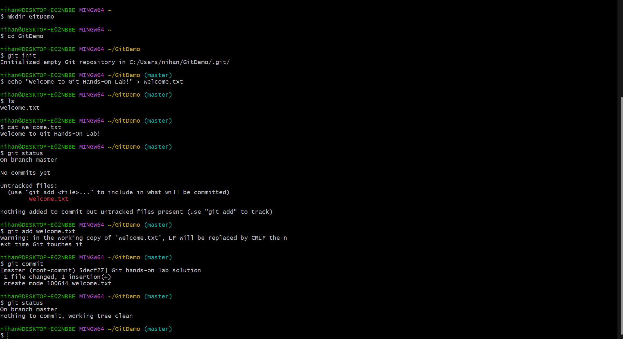

**OUTPUT :**

